Templafy add-in not loading in Office application

Resolution steps
Please ensure the respective Office application(s) are closed before continuing with the below steps.

- Open Registry editor
- Navigate to HKEY_CURRENT_USER\Software\Microsoft\VSTO\SolutionMetadata
- For each Templafy add-in vsto file (1), make a note of the Data GUIDs (2).
- Under the SolutionMetadata Registry Key, click on the corresponding GUIDs from step 3 (3).
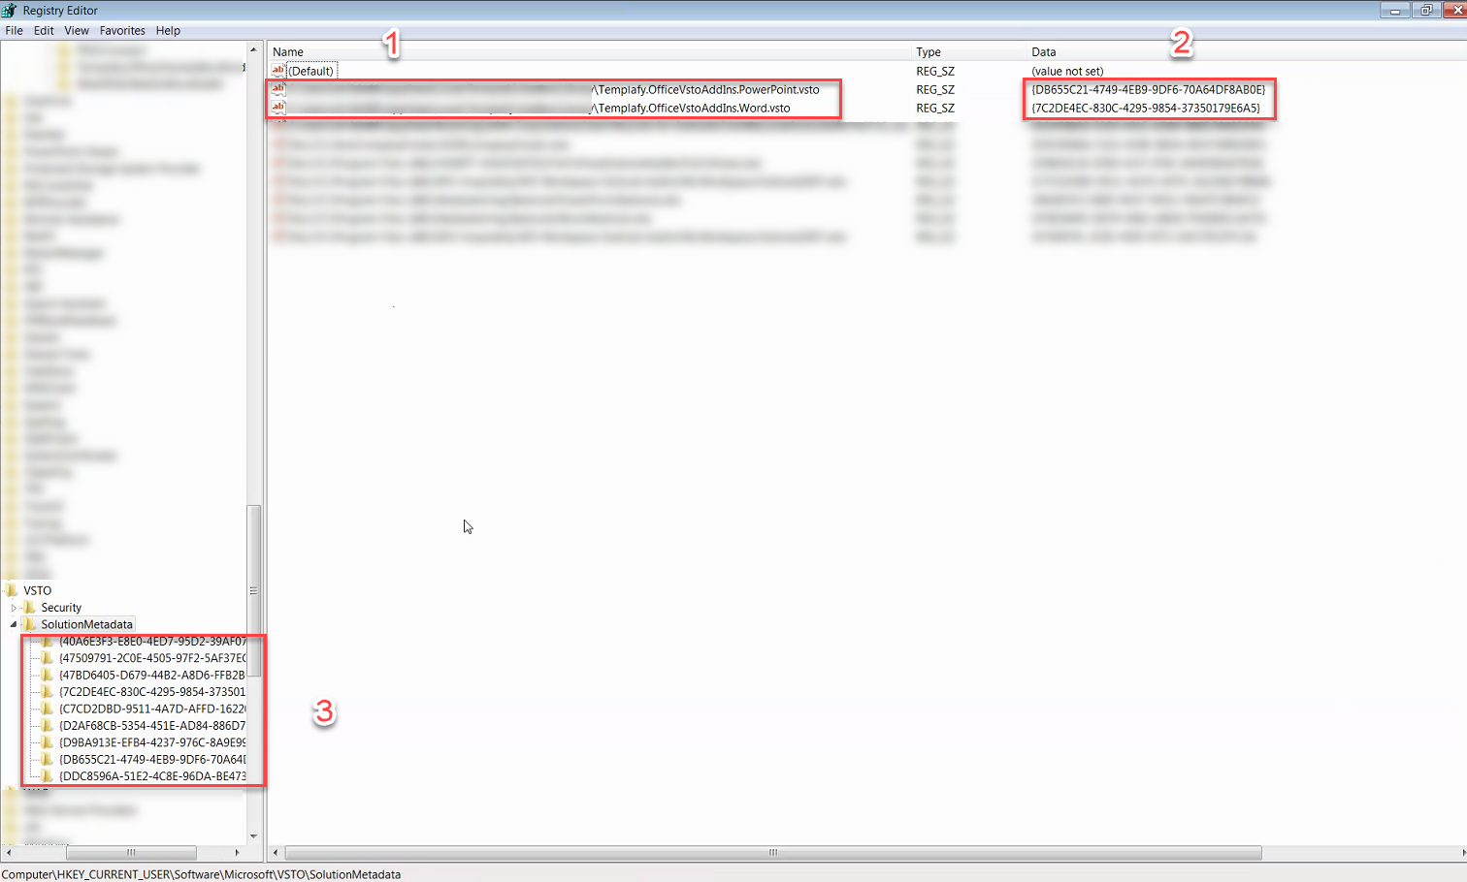

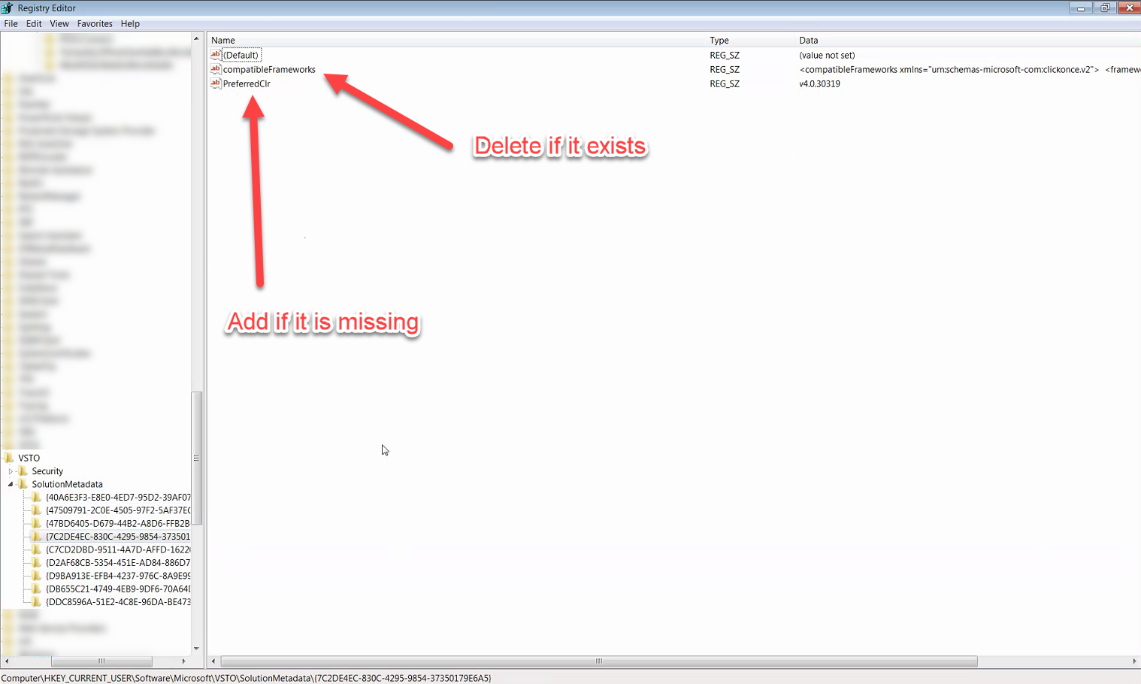
- For each Templafy GUID, ensure PreferredClr string value exists. If it does not, right click in the Registry Editor and create the String Value. If a string value compatibleFrameworks exists, right click on the name, and delete.

- Ensure LoadBehavior DWORD is set to 3 for the Templafy add-in in Word and PowerPoint. Navigate to the below registry paths to check and change this.

Computer\HKEY_CURRENT_USER\Software\Microsoft\Office\PowerPoint\Addins\Templafy.OfficeVstoAddIns.PowerPoint

Computer\HKEY_CURRENT_USER\Software\Microsoft\Office\Word\Addins\Templafy.OfficeVstoAddIns.Word

- Close Registry Editor.

- Start Word and PowerPoint to confirm the Templafy add-in loads.

